AI FITTRACK

AI-Powered Fitness Recommendation & Workout Management Platform

Project Title: AI FitTrack-API
Team Leader: Haproos Fathima.R
Team members: Sujithra.V
Thangavel.N
Roll no: 222411299
NM ID: 8EBAC48EA63ECE3A88743FDB623632B6
Course: B.Sc
Department: Computer Science
College: Vivekananda Vision Arts and Science College Katchur
Academic Year: 2026-2027
GitHub link:https://github.com/haproos1/AI-Fittrack-api.git
Demo link:https://drive.google.com/file/d/1Rars0YdH73Yr5eJz9cZgwmWtcrlh6A5h/view?usp=drivesdk

1. Introduction
AI FitTrack is an AI-powered fitness recommendation and workout tracking platform designed to simplify workout monitoring and provide personalized exercise guidance. The backend RESTful application enables secure user authentication, workout log management, workout search, and AI-driven recommendations.

Developed using Node.js, Express.js, MongoDB, Mongoose, and Google Gemini AI, the system provides workout tracking, activity analysis, and AI-generated fitness advice. The application implements JWT authentication to protect user records. The main objective of AI FitTrack is to deliver an organized platform for personal fitness tracking and AI-driven workout optimization.

2. Problem Statement
Fitness enthusiasts often manage workout routines manually using notebooks or spreadsheets. Manual record-keeping makes it difficult to maintain structured histories, monitor progress over time, or determine if exercises match personal goals.

Additionally, users frequently lack professional guidance when deciding appropriate workouts or evaluating performance metrics like calories burned and training intensity. AI FitTrack addresses these challenges by offering a centralized platform where users can securely maintain workout histories and leverage Artificial Intelligence for tailored fitness plans and performance insights.

3. Objectives
- To provide secure user registration and login functionality.
- To allow users to create, update, retrieve, delete, and search workout logs.
- To generate personalized AI workout plans based on age, fitness goals, and experience level.
- To generate AI-based fitness performance insights analyzing workouts, duration, and calories burned.
- To implement JWT authentication for API protection and data privacy.
- To store user profiles and workout data securely using MongoDB and Mongoose ODM.

4. Scope
- Centralized workout management with full CRUD capabilities.
- Search workouts by workout name, category, or workout date.
- AI-generated workout recommendations and weekly training schedules.
- AI performance insights based on exercise history and burn metrics.
- Secure login and authorization using JWT tokens and bcrypt.js password encryption.
- Robust, scalable backend utilizing Model-View-Controller (MVC) architecture.

5. Technologies Used
Technology | Purpose
Node.js | Runtime ecosystem executing server logic and backend services.
Express.js | Web framework for creating RESTful API endpoints.
MongoDB | NoSQL database engine storing user profiles and workout logs.
Mongoose | ODM library for data modeling, validation, and schema definitions.
Google Gemini AI | AI service generating workout plans and fitness insights.
JWT (JSON Web Token) | User authentication and stateless API route security.
Bcryptjs | Hashes user passwords securely before storing in MongoDB.
HTML & CSS / Postman | API consumers and UI testing client tools.

6. System Requirements

Hardware Requirements
- Processor: Intel Core i5 8th Gen or above) / AMD Ryzen 5
- RAM (8 GB minimum 16 GB recommended)
- Storage: 1 GB available disk space
- System: Windows 10/11, macOS, or Linux

Software Requirements
- Operating System: Windows 10/11 / macOS / Linux
- Runtime: Node.js (v16 or above)
- Framework: Express.js
- Database: MongoDB
- IDE:Visual Studio Code
- API Testing: Postman / Thunder Client
- AI Service: Google Gemini API

7. System Architecture
AI FitTrack follows a layered Model-View-Controller(MVC) architecture. The client application or API tester sends HTTP requests to the Express.js server gateway. Protected routes pass through JWT authentication middleware. Controllers process request parameters, interact with MongoDB via Mongoose models, and communicate with Google Gemini AI through a dedicated service layer to return structured JSON responses.

8. Modules

8.1 User Authentication Module
Provides registration and login features. User passwords are encrypted using bcrypt.js, and authenticated sessions issue JWT tokens for route protection.

8.2 Workout Management Module
Allows users to perform CRUD operations on personal workout logs including creation, retrieval, updating, deletion, and parameter-based search filters.

8.3 AI Fitness Guidance Module
Communicates with Google Gemini AI to deliver personalized routines and performance insights based on user metrics (age, goals, experience, calories burned, duration).

8.4 Error Handling & Middleware Module
Validates incoming request formats, verifies Authorization headers, and returns centralized, standardized JSON error responses.

9. Database Design

9.1 Database Used
MongoDB is used to store user credentials, profile information, and workout histories.

9.2 Main Collections
Collection | Purpose
Users | Stores name, email, encrypted password, timestamps.
Workouts | Stores user ID, workout name, category, duration, calories burned, date.

9.3 Database Relationship
- A User can create multiple Workout records One-to-Many relationship).
- Each Workout document is linked to a specific User via an ObjectId reference (user field).

10. Implementation

10.1 Backend Implementation
Built using Node.js and Express.js using MVC architecture to isolate routes, controllers, services, and database models.
10.2 Authorization and authentication
Passwords are hashed using bcryptjs before storage. Successful login generates a stateless JWT token sent in the Authorization header for protected endpoints.

10.3 AI Integration
The backend communicates with the Google Gemini API using a dedicated service module (geminiService.js) to generate workout recommendations and analyze performance stats.

10.4 API Implementation
- Auth APIs: /api/auth/register, /api/auth/login,
/api/auth/profile
- Workout APIs: /api/workouts/ POST, GET, PUT, DELETE, Search)
- AI APIs: /api/ai/workout-recommendation,
/api/ai/fitness-insights
11.Testing

Test Case | Functionality | Expected Result | Status
TC01 | User Registration | New user account created  successfully with encrypted password. | Pass
TC02 | User Login | Valid credentials return a signed JWT token. | Pass
TC03 | Profile Retrieval | Returns user details when valid Bearer token is provided. | Pass
Test Case | Functionality | Expected Result | Status
TC04 | Add Workout | New workout record saved in MongoDB linked to user  ID. | Pass
TC05 | Get Workouts | Retrieves list of workouts belonging to authenticated user. | Pass
TC06 | Update Workout | Modifies specified workout record parameters. | Pass
TC07 | Delete Workout | Removes workout log from database. | Pass
TC08 | Search Workouts | Filters workout list by category or name. | Pass
TC09 | AI Recommendation | Returns tailored workout routine from Gemini AI. | Pass
TC10 | AI Insights | Generates fitness analysis based on workout stats. | Pass

12.Advantages
  - Centralized tracking for all physical workouts and exercises.
  - Automated AI recommendations personalized to age and goals.
  - Actionable AI insights analyzing workout duration and calories burned.
  - High security using password hashing and JWT token validation.
  - Clean JSON responses facilitating seamless frontend integration.

13. Limitations
- AI features depend on active internet connection and Gemini API availability.
- Quality of fitness insights relies on accuracy of user-submitted exercise data.
- Currently restricted to backend REST API infrastructure.

14. Future Enhancements
- Integration with wearable fitness devices (smartwatches, activity trackers).
- Implementation of frontend dashboard using React.js or mobile frameworks.
- Nutrition and meal plan generation using AI models.
- Automated workout reminders and social sharing features.
15.project screenshot
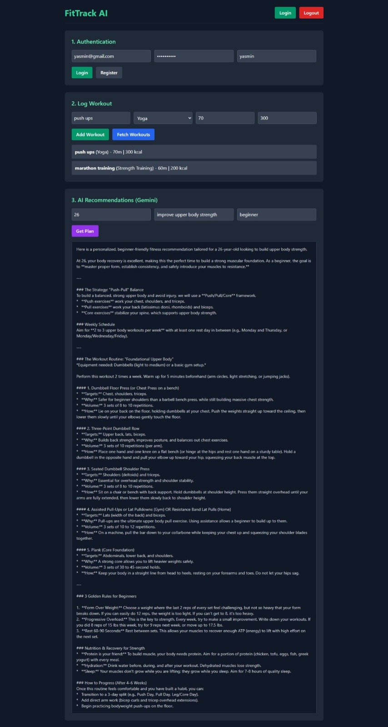

16. Conclusion
AI FitTrack provides a modern, secure, and scalable backend solution for workout management and personalized AI fitness guidance. Built with Node.js, Express.js, MongoDB, JWT, and Google Gemini AI, it effectively bridges traditional fitness tracking with intelligent automation.

16. References
- Node.js Documentation
- Express.js Documentation
- MongoDB & Mongoose Documentation
- Google Gemini API Documentation
- JSON Web Token JWT Standards

